

Lewis University, ABQ Campus

**Title**: Building Luxury Underwater Homes

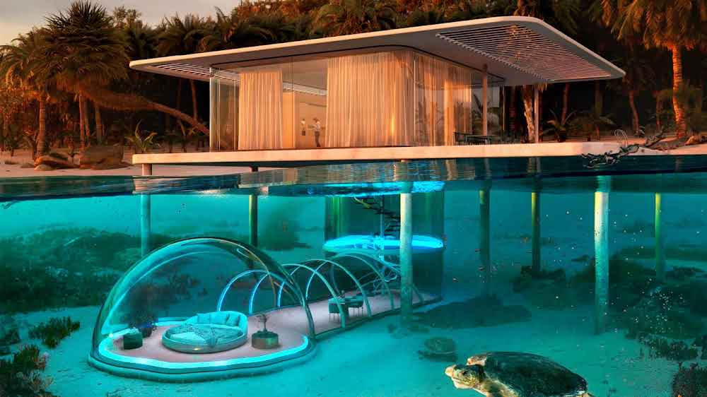

**GitHub Url:** <https://github.com/EX-sai/EX-sai.git>

**SQL Environment:** Windows.

|  |  |
| --- | --- |
| **Course code** | FA23-CPSC-50900-005 |
| **Course Title** | Database Systems |
| **Term** | Fall 2023 |
| **Professor** | Mr. Matthew Clavelli |
| **Submitted By** | Saidalli chukka |

**Part-1:**

Briefly describe your business, estimated company size in terms of people and locations, and your supply chain. Your supply chain consists of:

1. What your raw materials are (need at least 3)

2. Where you get your materials from (two sources per material)

3. Where your primary office is, and how many cities do you operate in?

**Business: under water homes**

**Business Description:**

Our fictional company specializes in the design and construction of luxurious underwater homes for clients who seek a unique and breathtaking living experience beneath the ocean's surface. We combine cutting-edge technology with innovative architectural designs to create exclusive underwater residences. These homes are not only a testament to human engineering and imagination but also a fusion of luxury and sustainability.

**Estimated Company Size:**

The company's size will depend on the demand for underwater homes and the scale of projects we undertake. Initially, we envision a core team of approximately 50 individuals, including architects, engineers, project managers, divers, and support staff. As projects grow, we can expand our team and collaborate with experts in marine biology, oceanography, and advanced technology.

**Supply Chain:**

To successfully design and build underwater homes, our supply chain is a critical aspect of our business. It involves sourcing the necessary raw materials, components, and technology while ensuring the safety and comfort of our clients.

**Raw Materials:**

Pressure-Resistant Materials: We need advanced materials capable of withstanding the immense pressure of the deep ocean. These materials may include high-strength alloys, reinforced concrete, and transparent materials for viewing areas.

Life Support Systems:

These systems are vital for maintaining a comfortable living environment underwater. They include air and water filtration systems, climate control technology, and waste management solutions.

Advanced Technology:

Our underwater homes will be equipped with state-of-the-art technology for communication, security, and entertainment. This includes custom lighting systems, underwater cameras, and remote monitoring and control.

**Material Sources:**

Pressure-Resistant Materials:

These specialized materials can be sourced from manufacturers specializing in marine engineering and materials science. We may collaborate with research institutions to develop proprietary materials.

Life Support Systems:

We can partner with companies specializing in life support technology for underwater habitats, such as those with experience in submersibles and underwater research stations.

Advanced Technology:

Technology components can be sourced from tech companies that focus on smart homes, underwater exploration, and surveillance equipment.

Number of Operating Cities:

Our company envisions operating in several strategic coastal cities that offer access to the ocean and a market for luxury underwater living experiences. Initially, we may establish operations in coastal cities known for their underwater beauty and marine biodiversity, such as cities along the coasts of the Caribbean, the Maldives, or the Mediterranean.

**Primary Office Location:**

The primary office, often serving as the company's headquarters, would be in a coastal city that is well-connected and has a strong infrastructure for research, design, and project management.

**Part-2:**

**Architecture Diagram**

**Github Link:** <https://github.com/EX-sai/EX-sai/blob/Underwater-Homes/under%20water%20homes.drawio>

